How to promote your cycle group on social media:

Rebrand:
We’ve rebranded from CTC to Cycling UK. It’s important that groups develop and grow with us and both stay consistent with each other. It would be wonderful if you could update your channels with our new logo to remain visually connected.

Facebook:
Facebook is a good organising tool, anything with a lot of information like events or articles, as well as lots of photos.

How to promote through Facebook:

- Set up a page for your cycling group through your own account:
Only you will be able to manage the page and post from the page but other people will see the posts under the page name rather than your name.

- Make a public Facebook page not just a private group!
A Facebook page is more accessible; everyone can see what is posted rather than just the people who have access to the group. If someone interested in cycling in Fleet wants to find a cycling group, they’re more likely to find a cycling Facebook page than a private Facebook group. Call your page something obvious and simple, like ‘Fleet Cycling’, something people are likely to search. Think about what you would type in if you were searching! Anyone who ‘Likes’ your page will get updated on what you’re posting via their newsfeed.

- From your new page, you can make groups and events:
Make an event under the name of your Facebook page rather than your own name. When you’ve made the event people have the option to click ‘Attending’. When someone clicks ‘Attending’, their Facebook friends can see that they are attending the event in their newsfeed. This means people who know about your group and attend events effectively do some promotion for you!

A great example of a Facebook post. It gives more information than on Twitter or Instagram and includes a link to the article it’s introducing.

Twitter:
Twitter isn’t as in depth as Facebook as you can only post 140 characters per post but it’s great for updates and links. It’s particularly good for current information and for publicising during an event.

How to promote through Twitter:

- Create hashtags for your group:
Creating a hashtag is as simple as putting the hashtag symbol in front of a word or phrase i.e. #cycling. If you click on the hashtag it will show all the other tweets using the same one so you can find people interested in the same thing. The more unique your hashtag, the more specific to you and your followers it is but the more generalised it is, the more widespread it will be and it’s more likely more people will see your tweet from clicking on the hashtag on another tweet. You can even use multiple hashtags per tweet.

- Tweet before and during events:
Tweet in the days or weeks before an event so people following you get reminders in their newsfeed. Tweet during the event to give live updates to people not at the event to encourage them to come along next time! You could even use a hashtag on these tweets like #livecycling #livetweeting.

- Follow people:
Follow people or companies interested in similar things. When you follow someone they’ll get a notification and are likely to click on your Twitter to see who you are and what you’re about. If they’re also interested, they’re likely to follow you back. Once they’re following you, they’ll see your tweets regularly!

A good example of a tweet. It uses a relevant event-based hashtag and includes a link for more information. A concise and informative tweet.

Instagram:
Instagram is predominantly pictures and can be used to make your cycling look brilliant, there’s filters and editing tools to enhance your images.

How to promote through Instagram:

- Post photos after events:
Typically, Instagram is good for posting one or two photos at a time and really choosing the best one, Facebook is the place for posting entire photo albums. Make your photos look lovely and really show what cycling is about to your group. You can use hashtags to gain attention, this time using generalised hashtags like #cycling #uk #roadcycling #countryside is best because they will attract people to ‘like’ your photo. The more ‘likes’ you get, they more people are likely to see your photo.

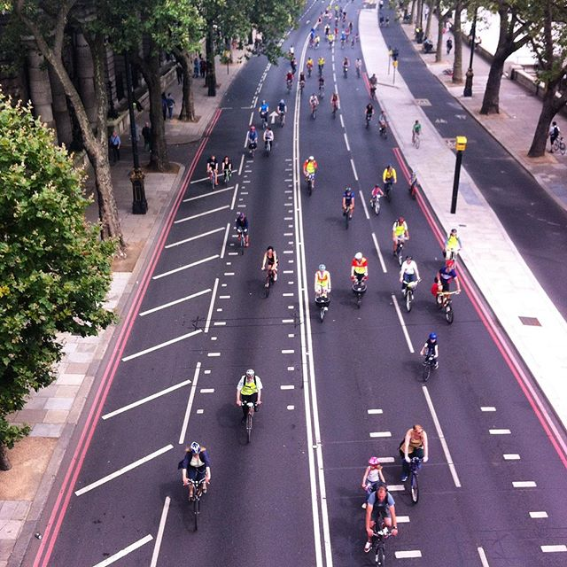

A good example of an Instagram image from Cycle UK’s Instagram (@wearecyclinguk). Nicely framed, creatively shot and looks exciting. Instagram is about being more creative with your photos rather than the standard group shot.

The hashtags used were: #joyofcycling #freecycle #ridelondon2016 #London #DrBike

E-newsletters:
E-newsletters are good for people not on social media as they only need an email account to receive them.

How to promote through E-newsletters:

- Attach your events and news
Write about what’s going on and how to get involved.

- Add your social media handles on the bottom of the email:
Tell your readers that they can find out more on your Facebook/Twitter/Instagram and try and get them involved.

Below is an example of an e-newsletter from a group from Sheffield. It shows their events coming up this week and how to sign up and get involved in a simple, clear way.

Photo Toolkit:
Tips on taking good photos for online media.

- Think about composition:
The rule of thirds is great for any photo, imagine a grid over your image and make sure that the points of interest in the photo either fall on a line or in a box, the horizon should be on the top of bottom line depending on your vantage point. Make sure that you don’t have excess empty space in the image (i.e. grass or sky), fill the frame with people and bikes.

- Think about diversity:
Does your photo look as though the group is only for women or only for 50+? Make sure the photo shows that the rides are accessible and open to all.

- Make it exciting:
Although photos of the entire group include everyone and enhance diversity, they don’t always represent the action of cycling. Go for individual shots with wonderful countryside or shots of small groups talking or laughing and not necessarily looking at the camera, people caught off-guard or naturally having fun make for better photos.

- Take more:
The benefit of technology, you have endless opportunity to get that perfect shot. Take more photos, you can always delete them if they’re not up to scratch.

A great example of the rule of thirds which also shows people having fun.

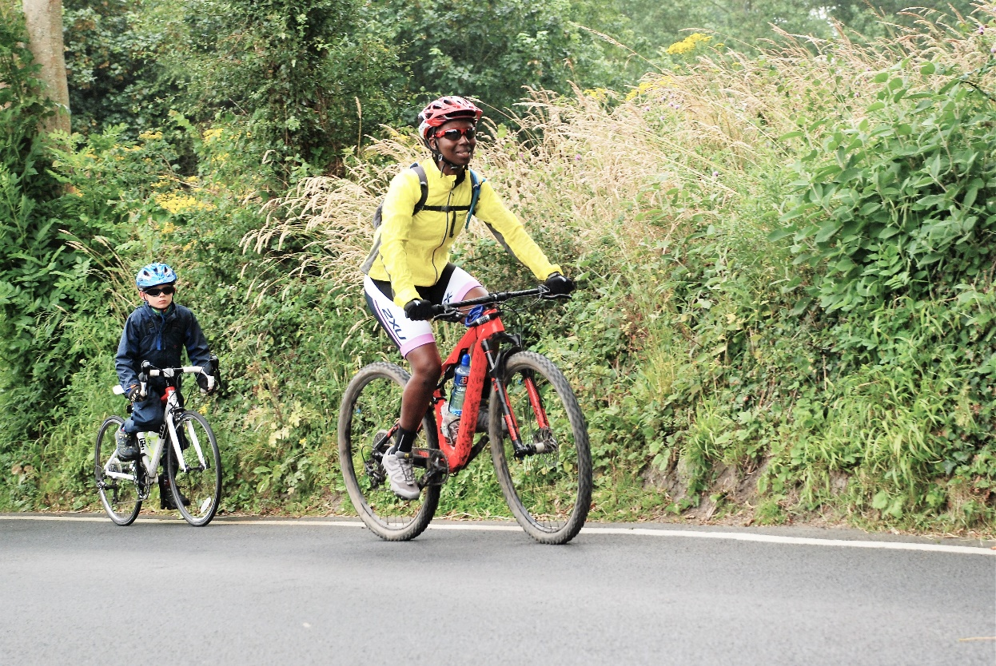
Another good example of the rule of thirds which also shows that cycling is accessible for children.
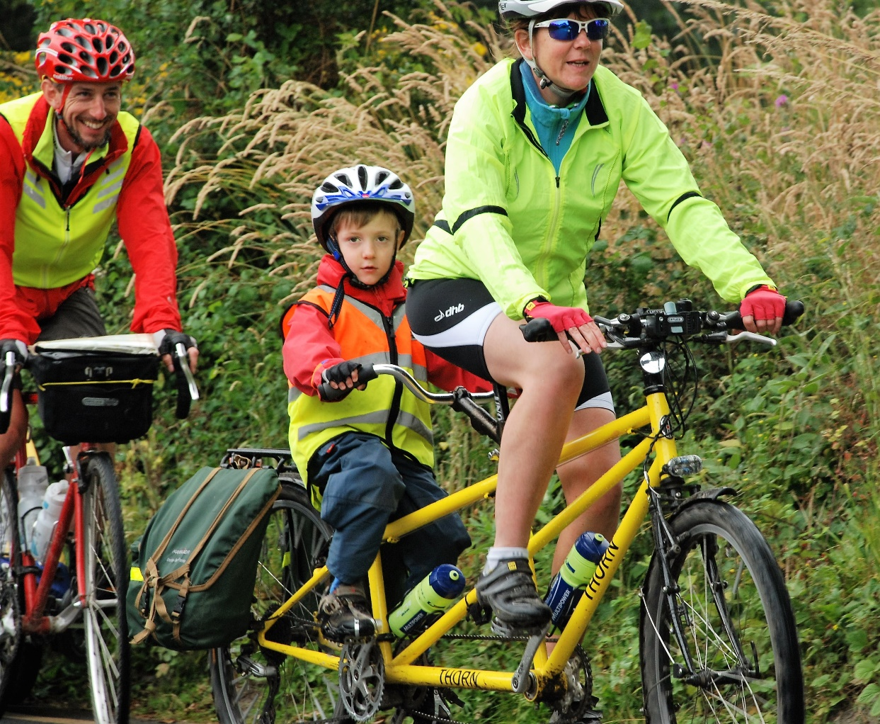
A diverse group with a good focal point, the frame is well filled and there’s no excess space.

Send us photos of your ride using the hashtag #CyclingUKGroups on Facebook, Instagram or Twitter after following this toolkit and get featured in CycleClips if they’re up to scratch!

Writing posts across social media:

- Be brief:
Don’t write about every tiny detail, only write about what’s really important.

- Be informative:
Draw your reader in and pick what you tell them carefully, you want them to be engaged and interested by what you’re saying so that they’ll come back time and time again.

- Add to your photos, tell us what we can’t see:
Steer away from describing the photos and add to what you know and saw beyond the image.

Top tips to be social media savvy:

- Hashtags:
Hashtags work across all social media, you can use them across Facebook, Twitter, Instagram. Make them specific to you but not so specific that people won’t think to search them i.e. #groupcyclingmarch2016 is too specific but #cycling is very generalised and will have been used millions of times.

- Combine your social media:
In the description boxes, add your names and tags on other forms of social media. I.e. In your ‘About’ box on Facebook, write ‘follow us on Twitter: @_______, Instagram: @________’ to connect your media outlets together.

- Be consistent:
Promote the same events across all your platforms so everyone will see even if they only have Twitter.

Other ways you can promote your group through Cycling UK:

- Use your group’s page on our website https://www.cyclinguk.org/local-groups to tell everyone about your group and then
- Upload your events and rides on to our website: https://www.cyclinguk.org/uk-cycling-events
- Write to us to get your events/rides included in CycleClips and/or in a feature on our website and other social media – email publicity@cyclinguk.org. Perhaps you have a particularly interesting anniversary or group event coming up or a group holiday that was memorable in some way that other members would like to read about?
- Write to the editor to suggest a feature in Cycle magazine eg Travellers’ Tales. Email: editor@cyclinguk.org
- Send us your own publications whether in paper or electronic format so we can see what you’ve been up to and then tell the rest of the cycling world. Post to Member Group Coordinator, Cycling UK, Parklands, Railton Road, Guildford, GU2 9JX.

